Swimming for non-swimmer

**chapter 1: water safe and learning to swim**

-help many people to improve and maintain health

-ability to fully enjoy any of these activities relies on knowing how to swim and how to be safe around the water.

**-drowning** (the process of experiencing respiratory impairment from submersion or immersion in liquid)

**Death by drowning** is a leading public health problem in the United States and throughout the world, but the majority of deaths by drowning can be prevented

**There are two keys to lowering the risk for drowning**: water safety education and knowing how to swim

International Life Saving Federation (ILS) Position Statement: Swimming and Water Safety Education

1. Death by drowning is a leading public health problem in all countries. Prevention requires public and government support.
2. Knowledge and understanding of water environments and their associated hazards should be taught to everyone at the earliest possible age.
3. Trained lifeguards should provide prevention, rescue and treatment where recreational swimming and water safety education take place.
4. Wherever possible, organizations with drowning-prevention expertise, based in high-income countries, should provide assistance to lower-income countries.

Water Safety Education

-Water safety education seeks to give people the knowledge they need to recognize potential risks posed by aquatic environments and activities and teaches them strategies they can use to lower those risks

-Water safety education also teaches people personal survival and water rescue skills,

Learning How to Swim

-Knowing how to swim is a basic life skill that everyone should possess

-Learning how to swim if you do not already know how can help you to feel more confident when you are in and around water, and it will open up a whole new world of opportunities for enjoying water-based recreational activities

-knowing how to swim can save your life or someone else’s life.

Choosing a Swim Instruction Program

-find a program that will best fit your needs. For example, think about whether you would prefer private, semi-private or group lessons

-**program qualities**,

**-instructor credential**

instructors should be trained by a nationally recognized training agency, such as Water Safety instructors trained by the American Red Cross.

-**class assignment, class size, class structure, instructor qualities , attention to safety.**

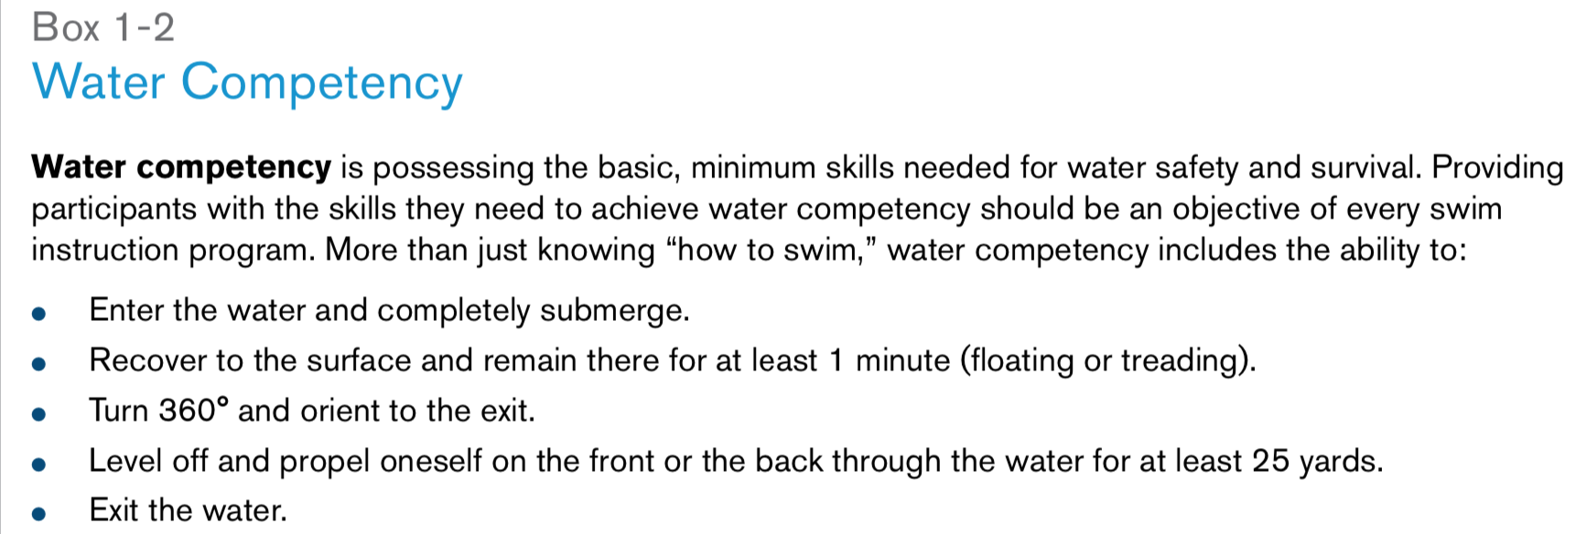

-The ability to demonstrate the skills that constitute water competency in one aquatic environment may not translate to another. For example, a person who is water competent in a pool may not be water competent in a lake, river or ocean because of different environmental conditions, such as cooler water temperatures or currents. Therefore, the definition of water competency should specify the environmental context.

Holding and Support Positions

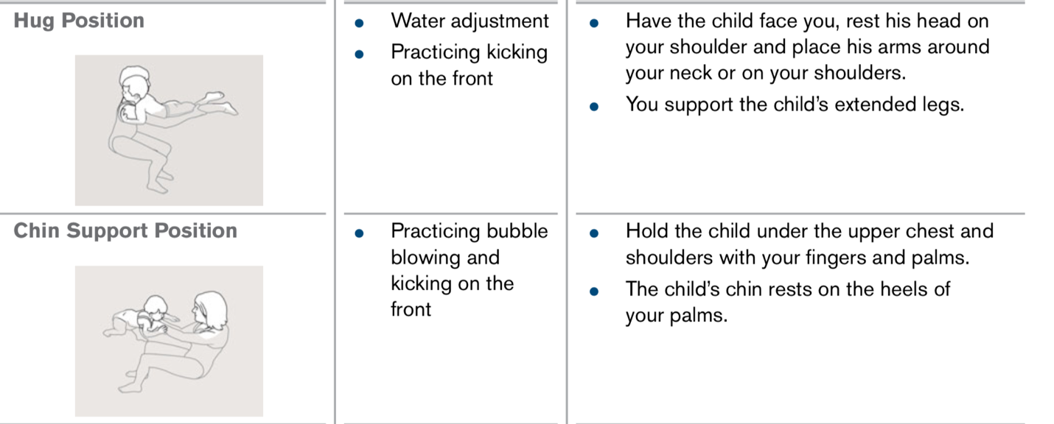

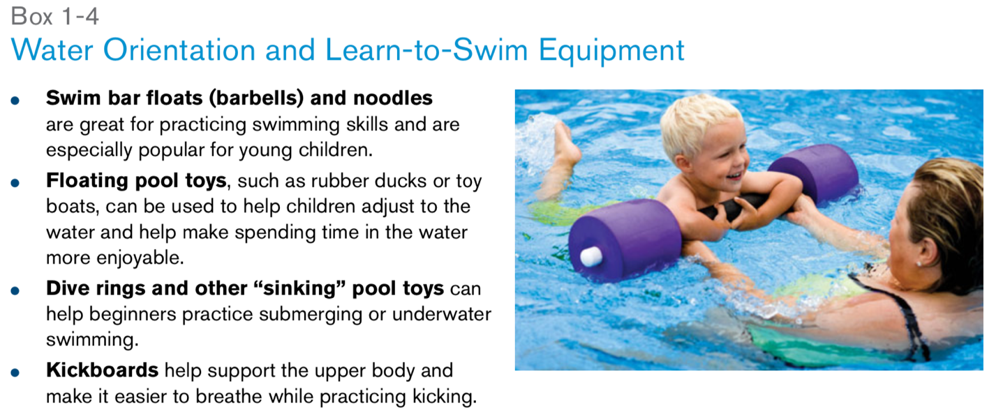

For the next 33 years, until his death in 1947, **Longfellow** worked tirelessly in support of the nationwide Red Cross Water Safety program.

As a result of his efforts, the nation’s drowning rate was cut almost in half—from 8.8 people per 100,000 in 1914 to 4.8 in 1947—and there was a tremendous upsurge in the popularity of swimming

**The Red Cross** has trained thousands of people to become water safety instructors, and millions of people have taken American Red Cross swimming and water safety classes.

American Red Cross Water Safety Courses

and Presentations

-The American Red Cross offers a variety of water safety education courses and presentations for adults and children.

-Topics range from specific interests (such as home pool safety, rip current safety, boating safety and basic water rescue) to general water safety education (such as Longfellow’s WHALE Tales, for children between the ages of 5 and 12

**Parent and Child Aquatics**

The American Red Cross Parent and Child Aquatics courses help young children between the ages of 6 months and approximately 3 years become comfortable in and around the water so that when the time comes, they are ready to learn how to swim **(Fig. 1-5)**

This is in accordance with the American Academy of Pediatrics statement that recommends that formal swimming lessons not begin until after a **child’s 4th birthday.**

**Preschool Aquatics**

American Red Cross Preschool Aquatics courses teach fundamental aquatic skills to 4- and 5-year-olds.

-The Preschool Aquatics course consists of three levels that teach fundamental water safety and aquatic skills.

Learn-to-Swim

The American Red Cross Learn-to-Swim course consists of six levels, focused on teaching school-age children and young teenagers how to swim skillfully and safely

chapter 2

Lowering the Risk for Drowning

-In the United States, drowning ranks fifth among the causes of death from unintentional injury.

-Lowering the risk for drowning requires following general principles of water safety **(Box 2-1)** and establishing layers of protection **(Fig. 2-1)**

**The American Red Cross has established five layers of protection for lowering the risk for drowning:**

-Learn swimming and water safety survival skills.

- Swim in lifeguarded areas.

-Have children, inexperienced swimmers and boaters wear U.S. Coast Guard-approved life jackets.

-Provide close and constant supervision to children who are in or near the water.  -Fence pools and spas with adequate barriers to prevent unsupervised access

Age is a major risk factor for drowning incidents. In the United States, drowning ranks second, behind motor vehicle crashes, as a cause of death from unintentional injury in children ages 1–14.  **Children between the ages of 1 and 4 years have the highest rate for drowning**. Most of these incidents occur in home swimming pools, but any source of water, including a bathtub or partially filled bucket,

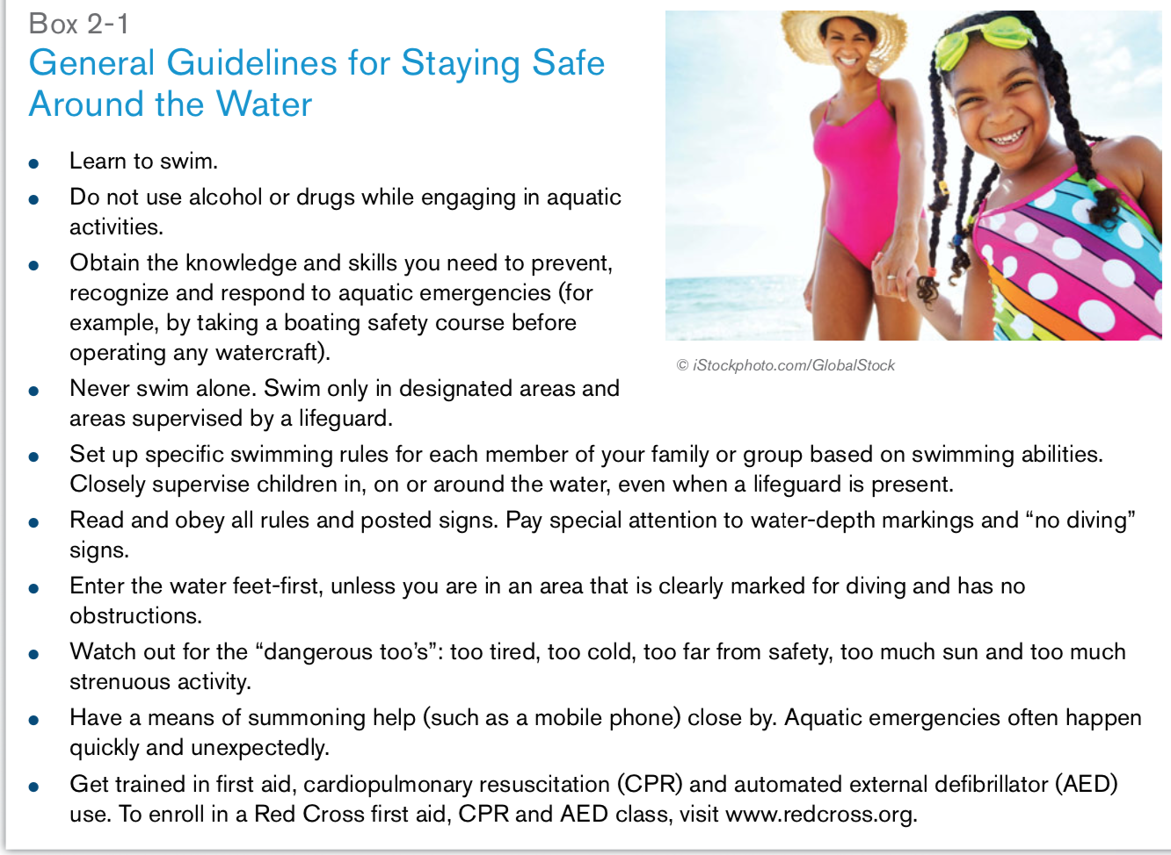

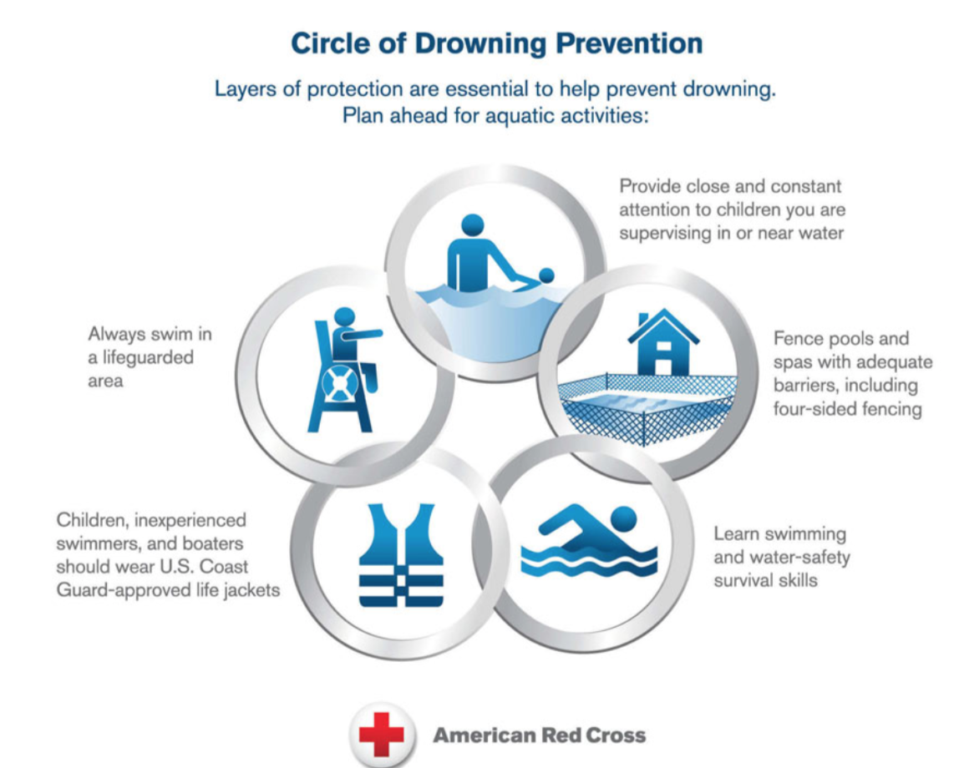

Using Life Jackets

Life jackets, also known as personal flotation devices (PFDs), are not just for boaters. Young children, weak or inexperienced swimmers and nonswimmers should also wear life jackets whenever they are in, on or around the water.

Life jacket:

-advantages: Offers the most reliable flotation  .  Comes in highly visible colors and may have reflective markings to aid search and rescue

-disadvantages: Bulky in and out of the water

Staying Safe from Environmental Hazards

Many aquatic activities provide a great opportunity to get outside and enjoy fresh air and sunshine. Make sure your experience stays enjoyable by being aware of environmental hazards and taking steps to protect yourself from them.

Sun Overexposure

-Overexposure to the sun has been linked to multiple health problems, including painful sunburns, skin cancer and eye damage (such as cataracts), and can cause premature aging and wrinkling(creased) of the skin.

Hypothermia

In hypothermia, the body is not able to keep itself warm and the body temperature falls far below normal. Hypothermia can lead to death if it is not treated

Inclement Weather

Thunderstorms

-Leave the water at the first sound of thunder or sight of lightning

- If you are in or around water and you hear thunder or see lightning, remember the 30/30 rule: take cover when the time between a flash of lightning and a roll of thunder is 30 seconds or less, and remain under cover until 30 minutes after the last flash of lightning was seen or the last roll of thunder was heard

-Remember the 30/30 rule: take cover when the time between a flash of lightning and a roll of thunder is 30 seconds or less, and remain under cover until 30 minutes after the last flash of lightning was seen or the last roll of thunder was heard.

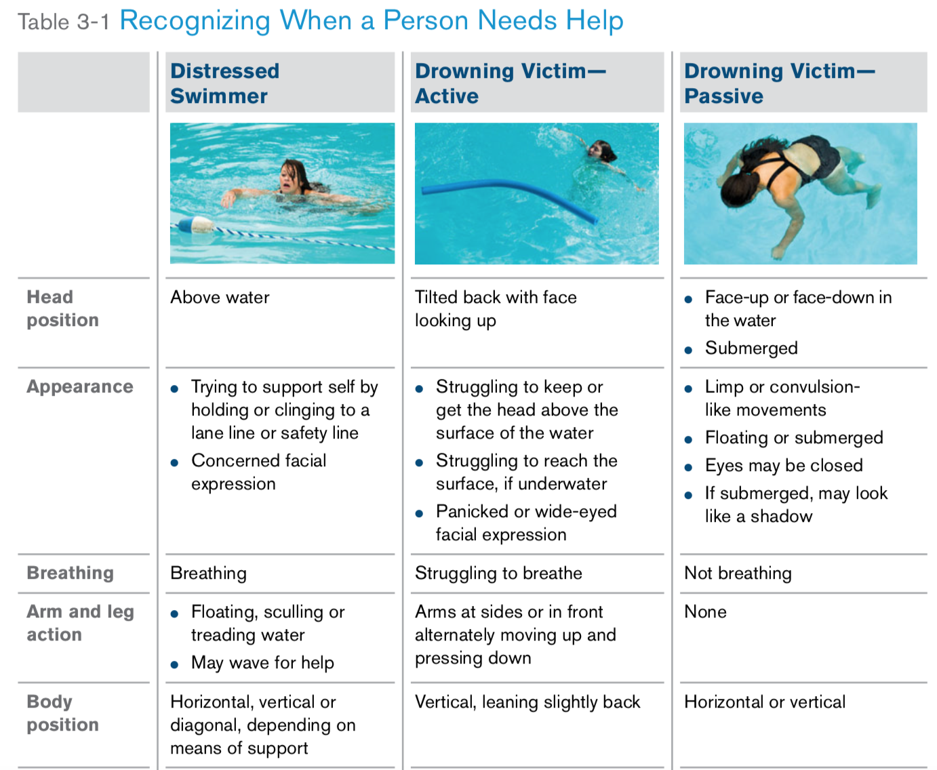

A distressed swimmer is someone who is not drowning, but needs help

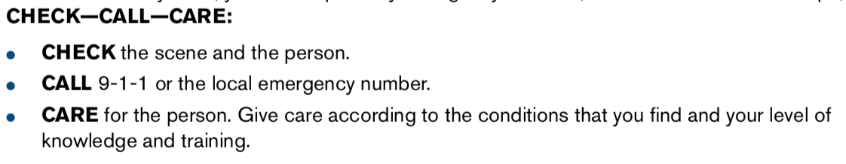

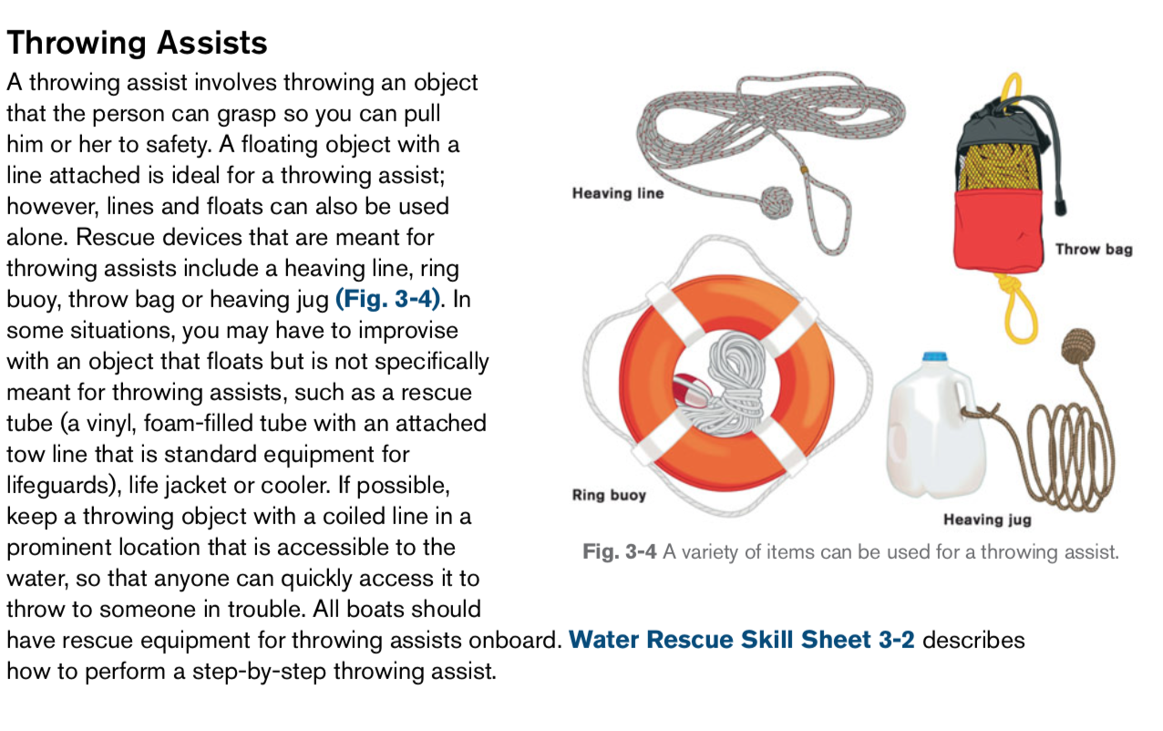

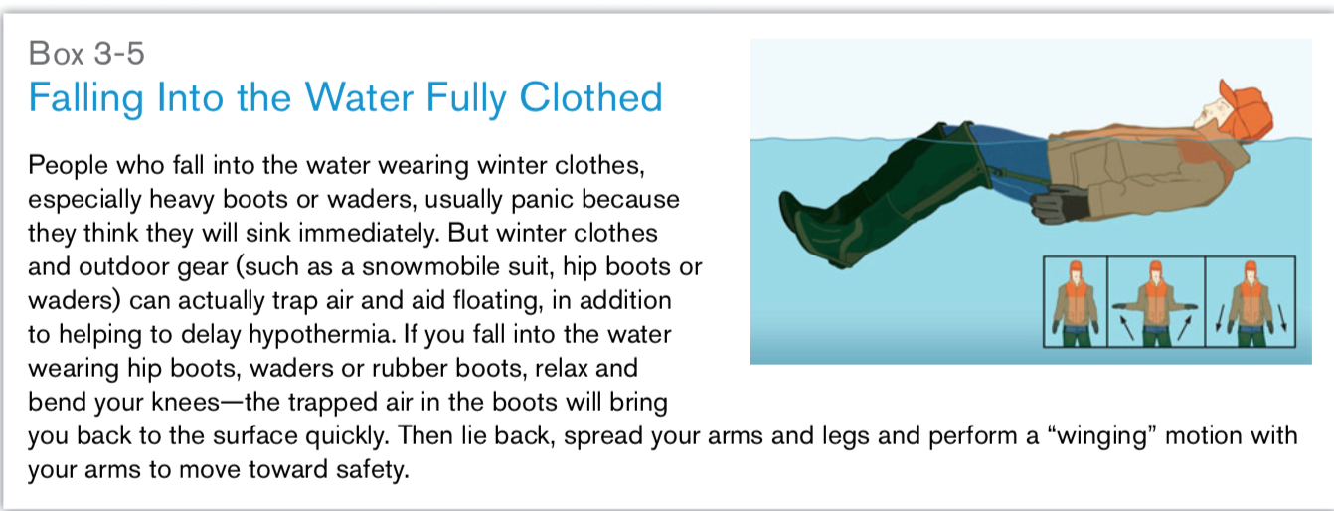

Chapter 4 : p

Understanding Hydrodynamic Principles

- the branch of science concerned with forces acting on or exerted by fluids

**Buoyancy**

**-** is the upward force that water places on an object when the object is in water.

- Water’s buoyancy opposes gravity’s downward force, which has the effect of lessening body weight in the water. Buoyancy is one reason aquatic therapy (physical therapy performed in the water) can be so effective for helping to restore or maintain function

- Buoyancy is also the reason that many people who have **mobility impairments(**lack of strength to walk) on land find it much easier to move in the water, because the buoyancy of the water helps to support the person’s body weight.

- Buoyancy allows swimmers to spend most of their energy producing forward movement rather than supporting themselves.

- Archimedes’ principle explains how buoyancy works **(Fig. 4-1)**.

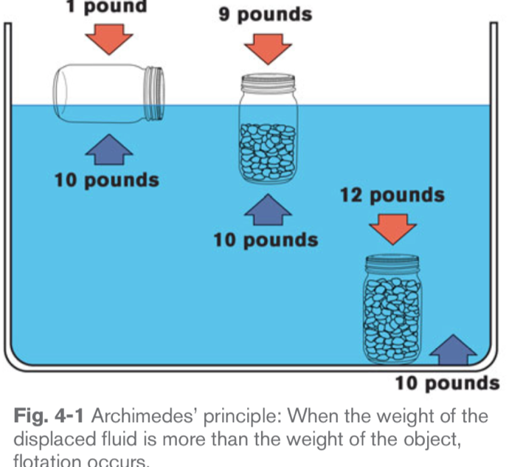

-This principle states that the buoyant force on an object is equal to the weight of the fluid displaced by the object

- Imagine three containers of the same size and shape. Each weighs 1 pound and can displace 10 pounds of fluid.

- **The first container** is left empty, sealed and placed in the water. It bobs high in the water with most of the container visible above the surface of the water

**- The second container** is filled with 8 pounds of pebbles(small stone), sealed and placed in the water. This container also floats, but much lower in the water than the first container

- **The third container** is filled with 11 pounds of pebbles, sealed and placed in the water. This container sinks because the weight of the container (12 pounds) exceeds that of the displaced fluid (10 pounds) .

Yet, if you tried to lift the third container while it was underwater, it would feel as if you were lifting only 2 pounds, instead of 12

Specific Gravity

-The amount of buoyancy exerted(applied) on an object is primarily determined by the object’s specific gravity.

**Specific gravity** is the ratio of the weight of the object to the weight of the water it displaces.

-**Pure water has a specific gravity of 1** . The specific gravity of other objects is the ratio of their density to that of water—**the object’s density divided by the density of water**

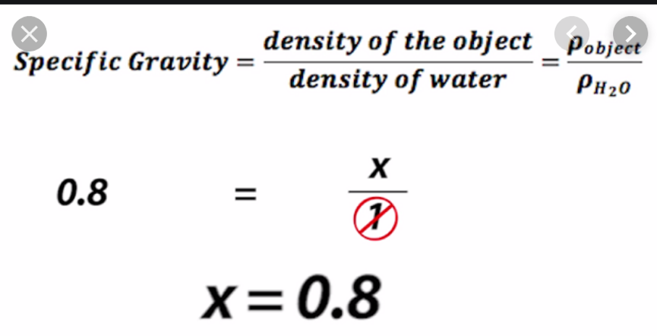

Objects with a specific gravity that is less than 1 will float. Objects with a specific gravity that is greater than 1 will sink.

**The first container**, which weighs only 1 pound but displaces 10 pounds of water, has a specific gravity of 0.1. This container floats high on the surface of the water because **its specific gravity** value is much lower than that of water

**The second container**, which weighs 9 pounds but displaces 10 pounds of water, has a specific gravity of 0.9. This container floats just above the surface of the water because its specific gravity value is only slightly lower than that of the water

**The third container,** which weighs 12 pounds but displaces 10 pounds of water, has a specific gravity of 1.2. Because its specific gravity value is greater than 1, the third container sinks.

Specific gravity explains why some people can float easily while others cannot **(Fig. 4-2)**, and why it is easier to float in salt water than in fresh water

-People with more body fat float more easily, whereas those with little body fat who are muscular or who have a dense bone structure do not float easily and may even sink.

- **Age and gender can also play a role in how easily a person floats**. In general, children are more buoyant than adults (because they do not have as much muscle mass and their bones are less dense), and women are more buoyant than men (because women’s bodies tend to have a higher percentage of body fat).

- The water also can make a difference in how a person floats. **Salt water** has more buoyant(ability to float) force because it has a higher specific gravity than fresh water. For this reason, a person who has trouble floating in a pool may find it easier to float in the ocean. Similarly, a person who floats easily in a pool will float even higher in the ocean.

- Finally, wearing a life jacket can increase your buoyancy because the life jacket displaces a large amount of water with only a minimal increase in weight.

**Center of mass and center of buoyancy**

-Specific gravity is not the only factor that affects how you float.

**Two other factors affect the position** of your body when you float: your center of mass (sometimes called your center of gravity) and your center of buoyancy.

**Two large forces act on the body** when a person is floating. One is the downward force of gravity. The other is the upward force of buoyancy.

-the **center of mass** is the location of all downward force and the **center of buoyancy** is the location of all upward force.

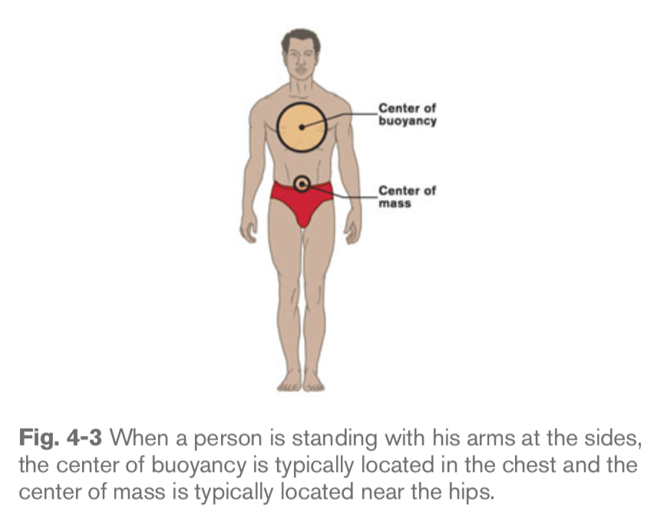

**-** When the center of mass is directly below the center of buoyancy, a person is able to float in a stable position.

**-** this happens because the two forces act on the body along the exact same line. If the center of mass is not directly below the center of buoyancy, the body will rotate until it achieves this alignment.

**-** Moving the center of mass and the center of buoyancy so that they are closer together increases stability during a horizontal float by minimizing the tendency of the body to rotate

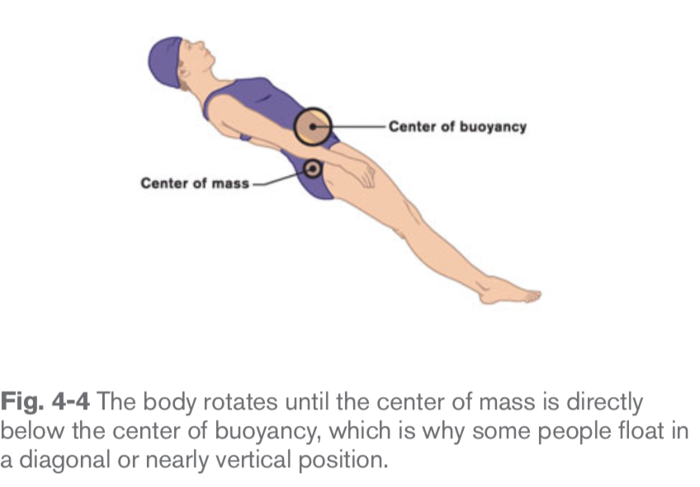

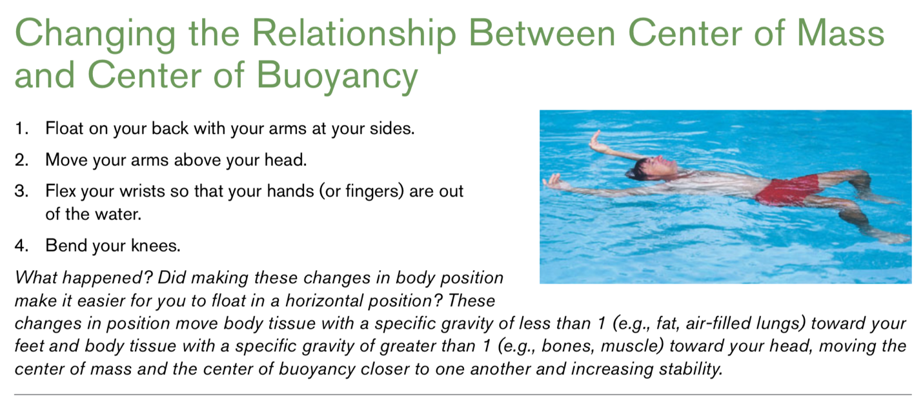

Drag

- **Drag** is the force that opposes movement through the water.

-Water, which is denser than air, creates resistance(opposition , ability to withstand off) as a person tries to move through it.

- However, swimmers seek to minimize drag because doing so helps them to swim faster and more efficiently.

**There are three main types of drag:**

-form drag, wave drag and frictional drag.

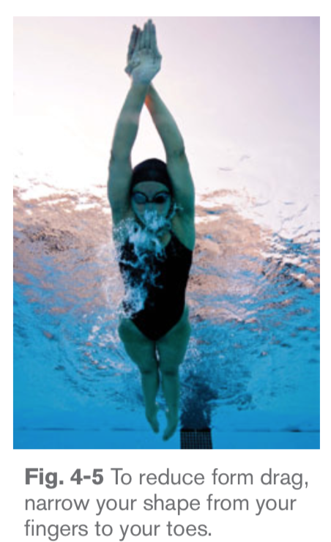

- **Form drag** is the resistance created by a swimmer’s body shape as the swimmer moves through the water. Form drag is the most significant contributor to overall resistance to movement through the water. However, form drag is the one factor that all swimmers can control to improve their efficiency when swimming.

- A tight, narrow body shape helps to reduce form drag

Wave Drag

- **Wave drag** is the resistance caused by turbulence(violent) in the water

-For example, wave drag is reduced when you take smooth, even strokes and **limit the amount of splashing** . Wave drag is also reduced, but not completely eliminated, when you move underwater, such as during starts and turns and in underwater swimming.

Frictional drag

**Frictional drag** refers to the resistance created by a swimmer’s body surface as it moves through the water.

- Wearing loose clothing while swimming dramatically increases this type of drag, which is why competitive swimmers wear smooth, tight-fitting swimwear or racing suits. Similarly, wearing a swimming cap and even shaving body hair can reduce frictional drag.

Propulsion

- **Propulsion** is the action of pushing or driving forward

- Swimmers are propelled through the water through a combination of kicking the legs and pulling water with the arms

**The forward movement that results is due to two types of propulsive forces at work:**

- drag forces and lift forces.

In the past, many thought that lift forces played the major role in propulsion. However, research has demonstrated **that drag forces** are actually the dominant form of propulsion in swimming.

**Drag propulsion**

- Drag (paddle) propulsion is based on one of Isaac Newton’s three laws of motion: the law of action and reaction. This law states that for every action there is an equal and opposite reaction.

To improve the efficiency and effectiveness of your swimming stroke, focus on maximizing drag propulsive forces.

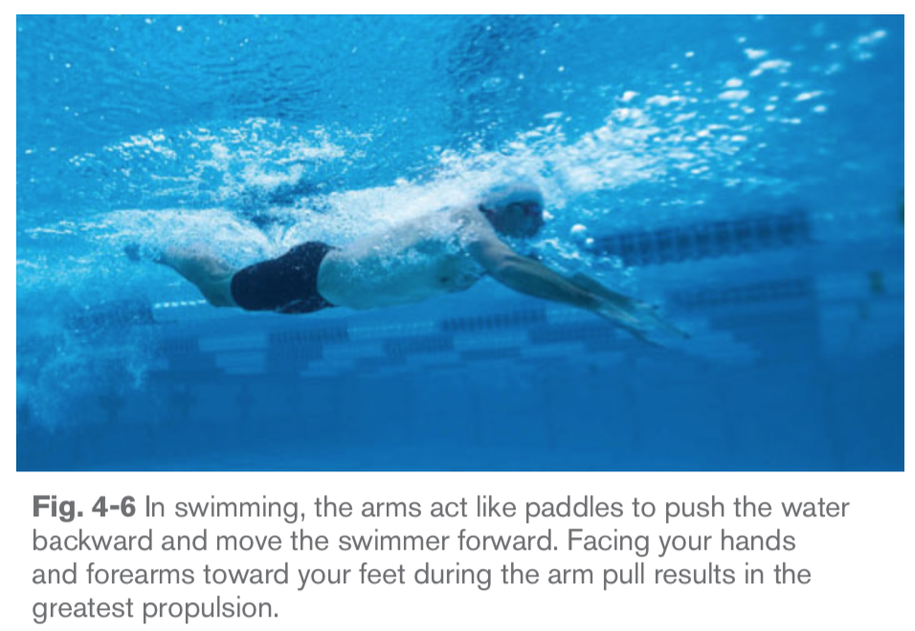

- In swimming, your limbs act as paddles to push water backward and move your body forward

- To create the greatest drag propulsive force when swimming, your hands and forearms should face toward your feet

One example of drag propulsion is the backward push of a paddle blade moving a canoe forward. Another is when a diver presses down on the end of the diving board and the board recoils, lifting the diver into the air.

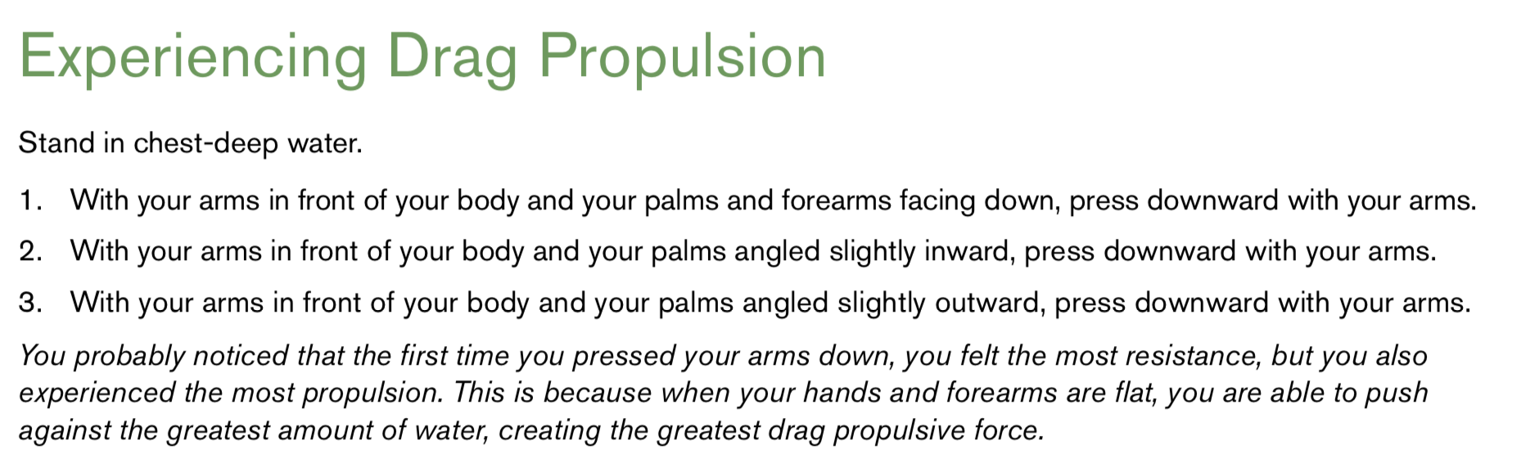

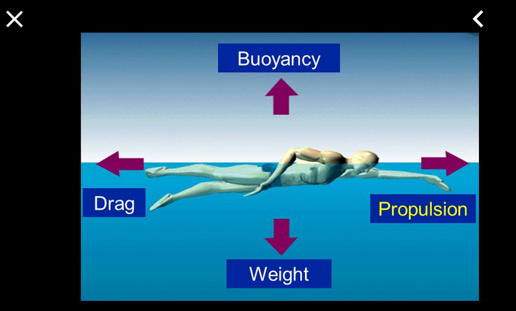

Lift Propulsion

While drag propulsion plays the dominant role in forward movement, lift propulsive forces help in overall propulsion

- The basic principle behind lift propulsion as it relates to swimming is that as fluid moves around an object, the individual particles within the fluid speed up or slow down to stay parallel with the particles on either side of the object

- The faster moving particles tend to lift the object as they try to remain parallel with the slower moving particles on the other side of the object.

- Lift propulsion is the natural result of several movements used in swimming.

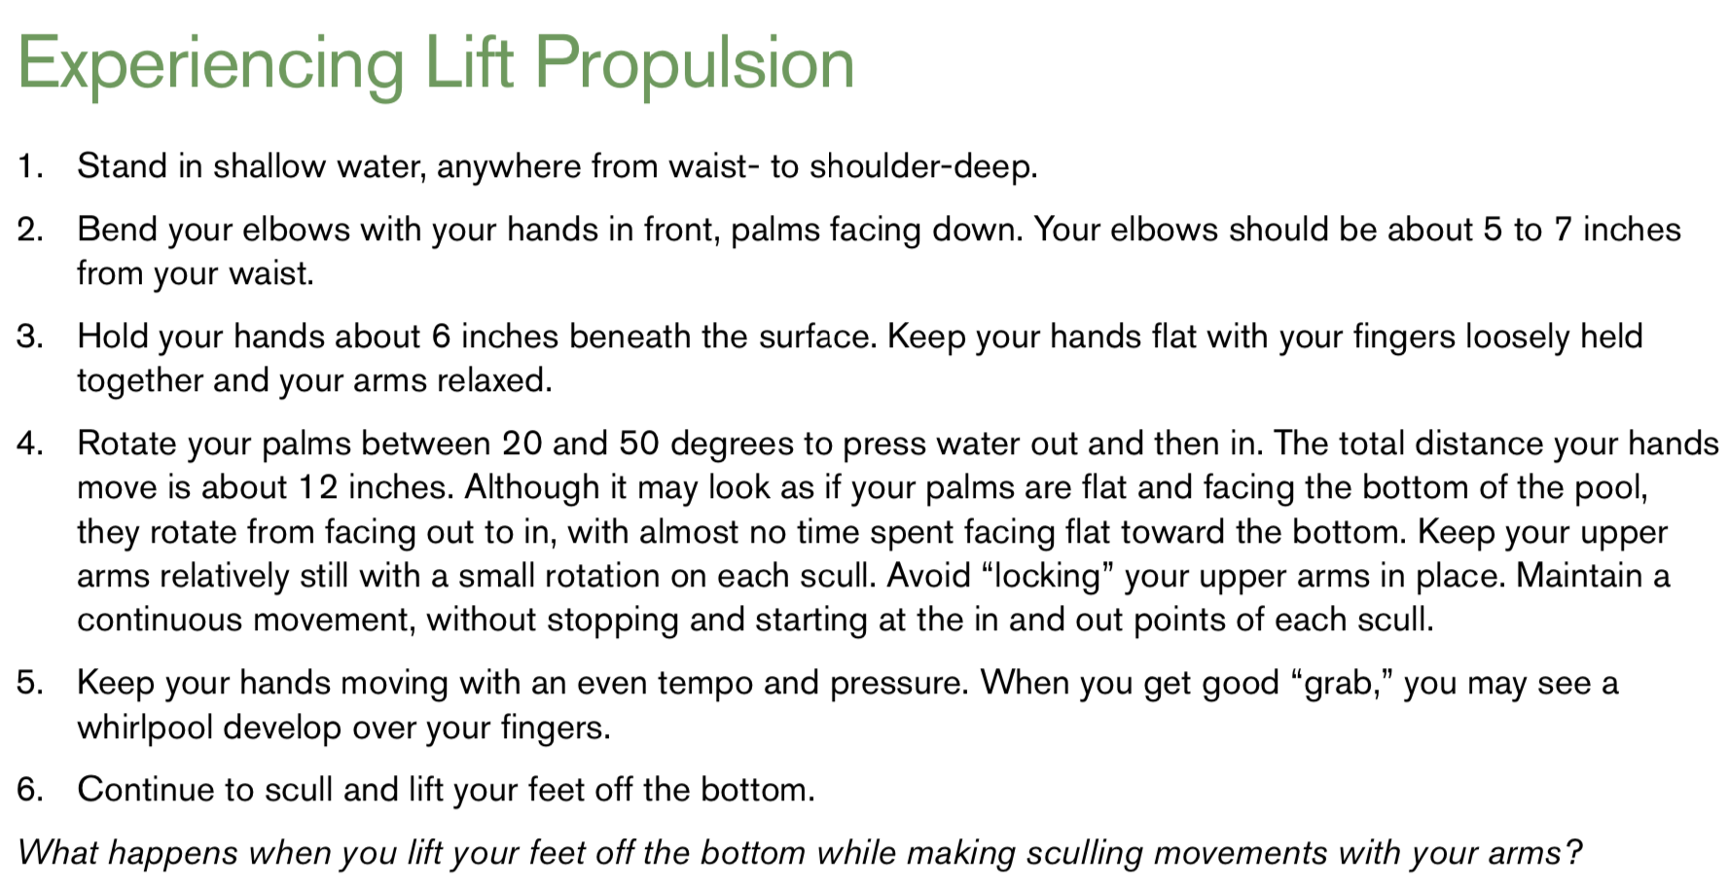

**Sculling (described in Chapter 5) is an example of lift propulsion (Box 4-5). In** sculling, the swimmer moves the hands, wrists and forearms to manipulate the flow of water and achieve lift.

Law of Inertia

-The second of Isaac Newton’s laws of motion is the law of inertia. The law of inertia states that an external force is needed to get a body at rest to begin movement, to stop a moving body, and to change the direction of a moving body.

Let’s look at each of these principles as they relate to swimming.

-An external force is needed to get a body at rest to begin movement. This simply means that more energy is needed to start a stroke than to maintain a stroke.

-Strokes that involve continuous motion, like the front crawl and back crawl, are most efficient but tiring. In strokes that incorporate a glide, like the elementary backstroke and sidestroke, inertia allows the swimmer to rest while still moving forward. However, if the glide is too long and the swimmer slows down too much, more work will be required to start the next stroke.

- An external force is needed to stop a moving body**.** The water is an external force that can stop a moving body. Swimmers need less force to keep moving when they are in a streamlined position than they do in other positions that create more drag.

- As speed increases, more and more force is needed to change direction. Incorrect body position, improper stroke mechanics or both can act as an external force on a moving body, causing the body to change direction unnecessarily. This is one of the reasons why beginning swimmers often have difficulty swimming in a straight line.

Law of Acceleration

- Newton’s third law of motion, the law of acceleration, states that the change in speed of an object depends on the amount of force applied to it and the direction of that force

This law relates to swimming in two ways.

- First, the more force a swimmer applies when pushing water back, the faster he or she will swim.

- Second, concentrating all propulsive force in one direction and maintaining that direction makes swimming more efficient.

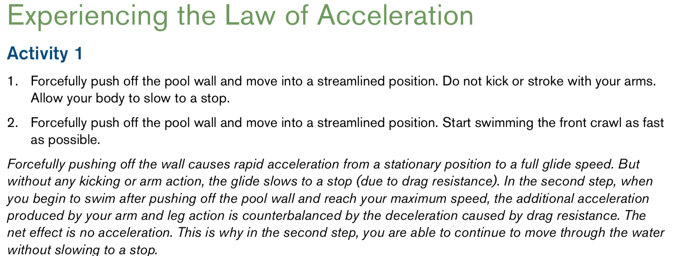

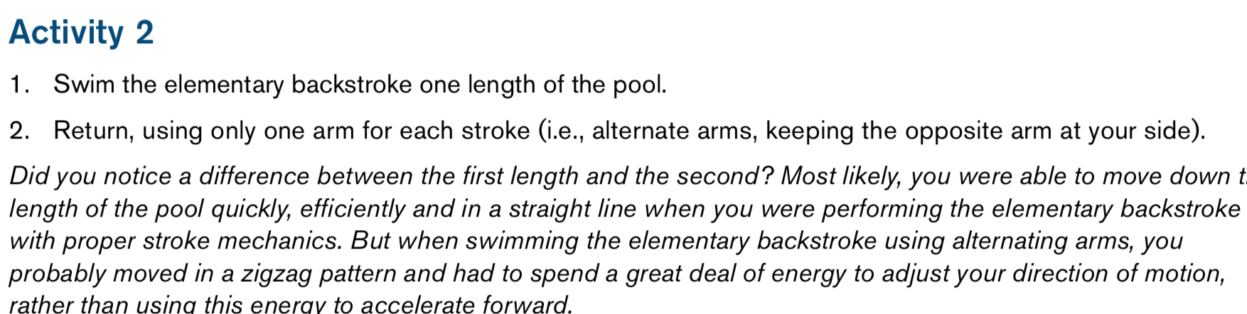

Law of Levers

A lever allows a person to do more work using less force.

- A lever consists of a pivot point and one or two rigid parts, called arms.

- The law of levers states that the product of the force applied and the length of the force arm is equal to the product of the resistance encountered and the length of the resistance arm

